Rendering Photorealistic Mountain Terrain

using PERLIN noise height map, intelligent multi-texturing & Directional Lighting  
<http://www.cs.rit.edu/~kkm6815/project/>

By  
**Karteek Mekala**

Supervised by  
Professor Warren R. Carithers  
Department of Computer Science  
B. Thomas Golisano College of Computing and Information Sciences  
Rochester Institute of Technology  
Rochester, New York

November 2014

**Approved By:**

__________________________________________________________  
Warren R. Carithers  
Associate Professor, Department of Computer Science  
Primary Advisor

__________________________________________________________  
Dr. Joseph Geigel  
Professor, Department of Computer Science  
Reader

__________________________________________________________  
Sean Strout  
Senior Lecturer, Department of Computer Science  
Observer

Acknowledgement

First and foremost, I would like to express gratitude to all the instructor and professor I’ve met through my years at the Department of Computer Science at Rochester Institute of Technology, especially Professor Warren Carithers and Professor Joe Geigel who introduced me to the world of Computer Graphics and taught me the nuts and bolts of a topic that I have been extremely curious and passionate about through the years leading up to my Master’s program. I would also like to thank my academic advisors for providing me with guidance and help through my course.

I would like to thank all the friends I made at RIT who not only made my experience at RIT fun and memorable, but were also a huge learning resource through discussions and team efforts. And last but not the least, I would like to thank my parents for all their love, support and encouragement that has helped me achieved all that I have to this day.

Abstract

Whether you are driving a tank through a war zone or watching a plane fly across Colorado, a common scene in many video games and animated movies is that of a beautiful mountain terrain. The primary goal of this project is to render a 3D scene of photorealistic mountain terrain that is vast and can be navigated using a fly through camera. Performance statistics gathered from the working demonstration are expected to prove that the implemented techniques are both performant and scalable. The techniques used to implement the solution are intended to be intuitive and options in the working demo will allow the user to understand the contribution of each stage in isolation. This will allow these techniques to be understood before being adapted into larger projects. The solution will also be made customizable to assist the same.

To render the scene - we first generate a map of heights. Using these heights we generate a list of triangles that can be rendered as a wire-mesh of the terrain. Multiple layers of grass, rock and water textures are applied to these triangles intelligently to mimic the look of real terrain. Lighting is applied, a skybox is rendered and a fly-through camera is provided to navigate through the scene.

Table of Contents

Acknowledgement 1

Abstract 2

Introduction 5

Background 5

Approach 6

Scene Description 6

Techniques 7

Height Map 7

Tessellation 8

Calculating Normals 9

Lighting 9

Multi-Texturing 10

Skybox 11

Camera Controls 11

Performance Statistics 12

Challenges 13

Sharp Transitions 13

Stretching of texture in areas with high slope 13

Sea level transitions 13

Clipping 13

Skybox Edges 13

Design and Implementation 14

Window Creation 14

Render System 15

Render Loop 16

Render Frame 17

User Interaction 18

Class Diagram 19

Technology 21

Development System Specifications 21

Software Development Kits 21

Development Environment 21

Program User Guide 22

Running the program 22

Input 22

Screenshots 22

Conclusion 23

Future Enhancements 24

Shadow Mapping 24

Tessellation Shader 24

Terrain Editor 24

Ocean Shader 24

User Interface 24

Segway to a Game Engine 24

Deliverables 25

References 25

Author Information 26

# Introduction

Photorealistic simulation of mountain terrain is part of many beautiful outdoor scenes in video games and animated movies. However, the application of mountain terrain rendering is more than just being used to show vibrant landscape. It forms the foundation over which many virtual environments are built upon. This ranges from depictions of outdoor farms to city experiences. Therefore it becomes essential for these programs to be performant along with being able to yield photorealistic and beautiful scenes. While rendering in real-time, it is even more important to maintain a high frame-rate. This project intends to use techniques that are intuitive and result in the targeted photorealistic image while still being scalable and performant. This is also made possible by making use of the high power GPU’s and CPU’s along with the advanced shader pipeline provided with the latest graphic development tools.

The techniques used to implement the solution are intended to be intuitive and options in the working demo will allow the user to understand the contribution of each stage in isolation. This will allow these techniques to be understood before being adapted into larger projects. The solution will also be made customizable to assist the same.

# Background

A lot of work has been done in terrain rendering due to its vast applications in movies, video games and digital art. Various techniques can be applied at different stages of the implementation.

Historically, many fractal algorithms have been used to implement terrain. In 1979-1980 John Carpenter presented a video accompanying his SIGHPRAGPH paper – “Computer Rendering of Fractal Curves and Surfaces”. This paper introduced techniques to synthesize fractal geometry and apply it to rendering. The following image is from his movie, demonstrating its application to render fractal terrain.

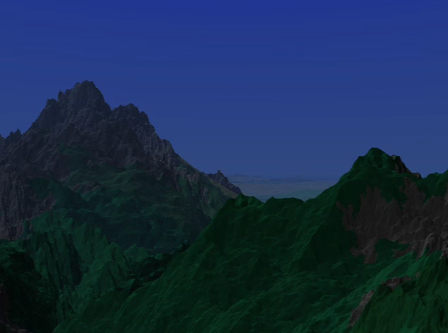[1]

The fractal technique employed here to construct the terrain is a subdivision technique. We start with a fractal curve composed of two end points and a roughness factor to be used as an offset. We then calculate a midpoint by choosing a constrained random process. The calculated midpoint then forms a common endpoint to the two resulting fractal sub-curves. This process of subdivision is repeated to arrive at the required terrain height map. The choice of the roughness factor and the random process determines characteristics of the resulting terrain.[1]

A common variant of the above technique is the ‘Diamond Square’ recursive subdivision algorithm. This technique starts with height values for the four corners of a rectangle. A random value within a fixed range is added to the average of these four values. This value is applied to the center of the rectangle, therefore subdividing the rectangle into four smaller diamonds. Applying the same process to each diamond results in squares again. This recursive subdivision is continued to generate an array of height maps. [6]

In our implementation we use the Perlin noise generator to generate a 2 dimensional array of heights. The Perlin noise generation technique was introduced by K Perlin. The general idea of the proposed algorithm was to a produce pseudo random signal over 3 dimensions that seems like it has been run through a low-pass filter – that removes high spatial frequencies. A 2 dimensional snap shot of the generated noise can be encoded and saved as a resource file that the terrain rendering program can consume. [4]

Once the height map is generated, various tessellation techniques can be applied to each primitive provided by the height map generator. Using sophisticated techniques can result in more natural looking terrain with roughness and bumps. Less sophisticated techniques will result in a more flat appearance. Lighting the terrain scene by itself can be a challenging task and various models of lighting can be implemented. Depending on the scene requirement - directional lights, spot lights, light sources and shadows be implemented. For the purpose of this project a simple directional light is implemented using the Phong Illumination model.

Once the wire mesh of the terrain is available, we must apply color to the scene. This can be performed either using procedural techniques or texture mapping. Procedural techniques calculate the color of each pixel on the terrain procedurally using various mathematical models. Texture mapping techniques use pictures of real terrain elements and blend them together.

Many 3d modeling tools are now available that allow artists to author beautiful looking terrain that can then be used as part of a scene or a video game. While advances in graphics hardware and software have made it possible to achieve beautiful real-time rendering of terrain using such modeling tools, it is still a challenging task for a vast terrain to be authored by an artist. The techniques introduced by this technique are intuitive and can be easily customized and adopted into other projects. It is also a performant and scalable solution to ensure that resources are available to create more complex and interactive environments over the terrain.

# Approach

## Scene Description

The goal of this project is to render a photorealistic mountain terrain scene with grass, rock and water. The distribution of rock and grass on the terrain along with the implementation of directional lighting will mimic what is expected in real mountain terrain. A skybox is rendered around the mountain terrain to contribute to the photorealism of the scene. A fly through camera is provided with user controls to navigate through the scene. The real-time performance statistics will be available by the use of debug controls given on the keyboard. To understand the techniques applied at each stage in isolation, the scene can be rendered as a wire-mesh, lighting can be disabled and other parameters can be adjusted by the use of the debug keys.

## Techniques

The following techniques will be used in their respective stages of the program implementation. The first step is to generate a grid of heights for which we use the Perlin noise generation algorithm. These heights will be converted into a list of triangles in the tessellation stage. The normals at each vertex will then be calculated at each vertex by applying simple vector geometry. These normals will used in the lighting and texturing calculation. The lighting and texture calculations will use intuitive techniques that work for achieving a photorealistic look for the scene. A fly-through camera is implemented using vector geometry and a simply skybox is rendered.

### Height Map

The height map resource file will be generated by storing the output of the Perlin noise algorithm in the form of a grey scale bitmap. The resource file will be put through a smoothing face to avoid sharp transitions in height values. The height map encoded into the grey scale image will be saved as a bitmap file for the terrain rendering program to read.

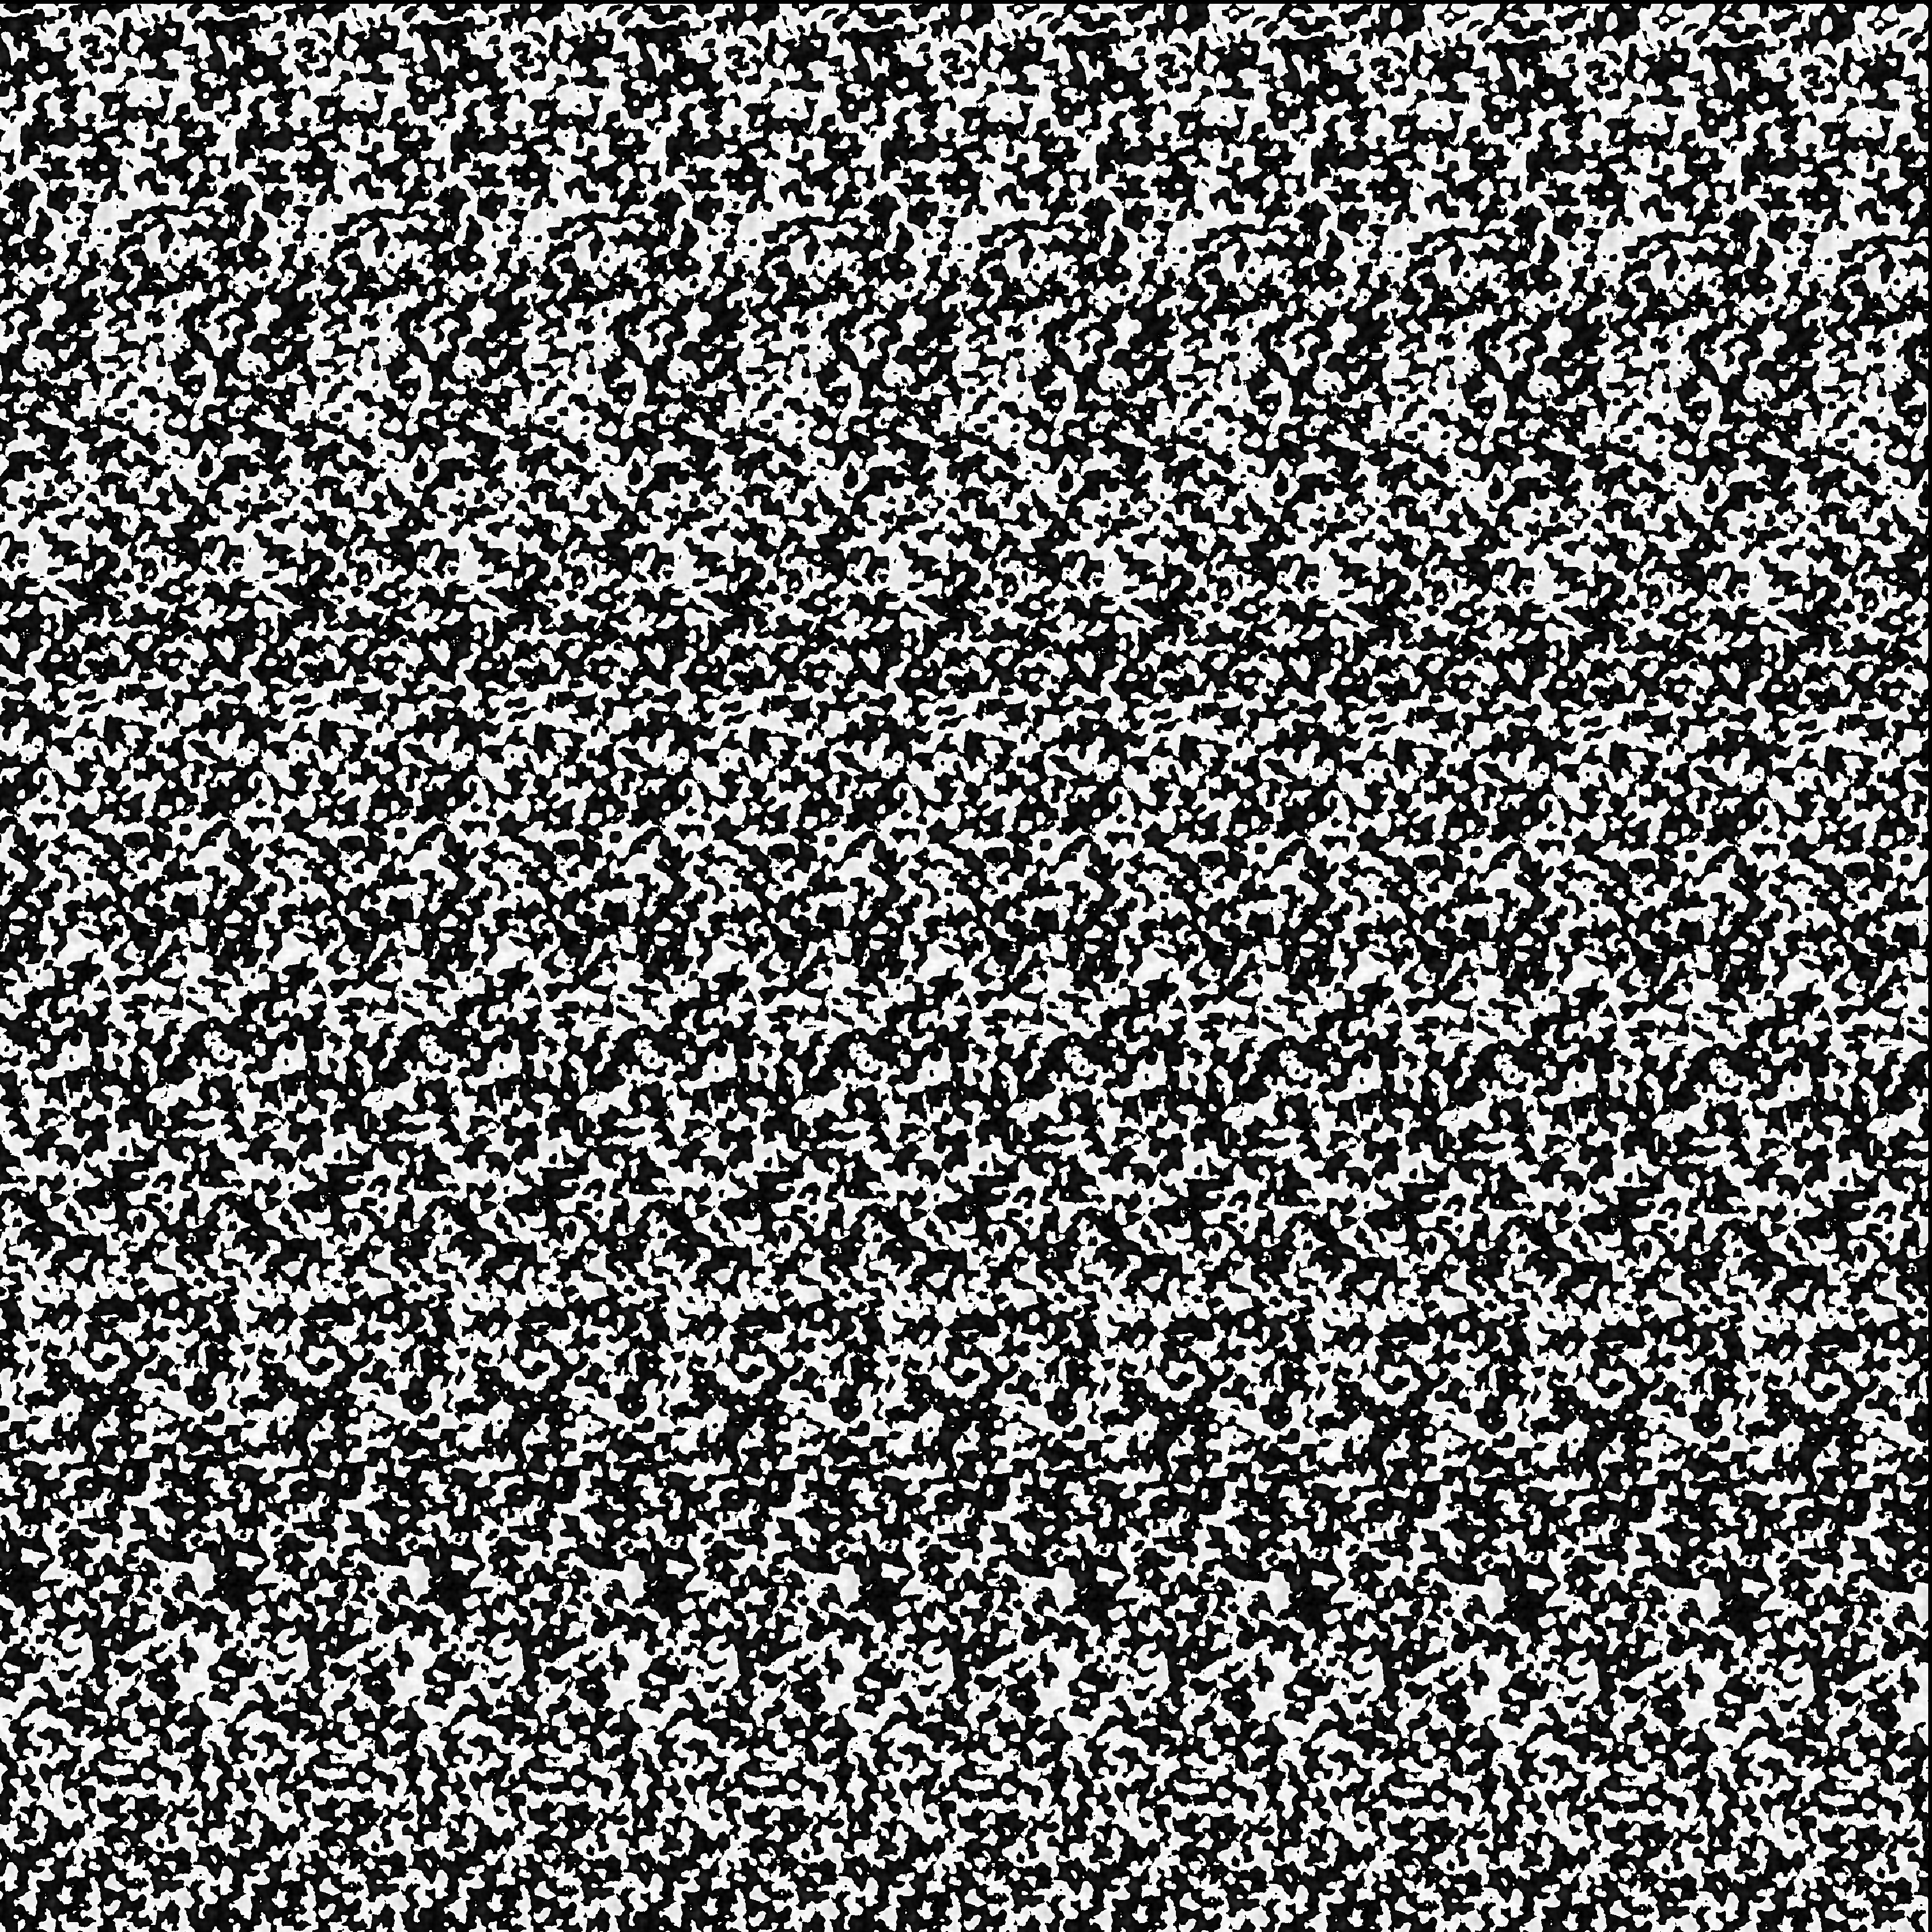

The Perlin noise algorithm is used to generate smooth noise. Using a regular random number generator would result in extremely harsh values that cannot be interpolated easily to look like terrain. The Perlin noise generator provides smooth random values that can interpolated and used as height map values of terrain rendering.

Perlin noise is better understood in 1 dimension and then applied to 2 dimensions. In a single dimension a noise function can be used to generate values between 0 and 1 at various integer sample points. Plotting this on a graph would like this:

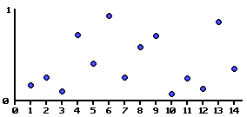[4]

By interpolating these values, we get a smooth function.

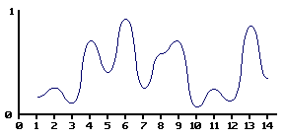[4]

Now by varying the amplitude and frequency we are able to get these noise functions:

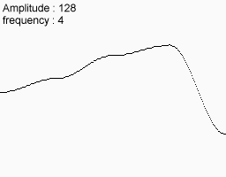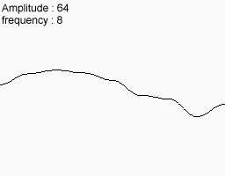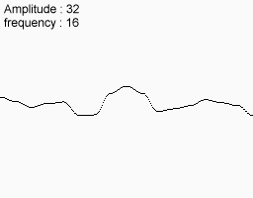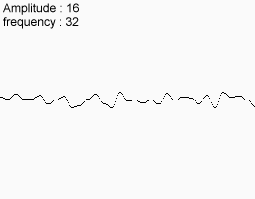[4]

By adding these values together we get a smooth noise function:

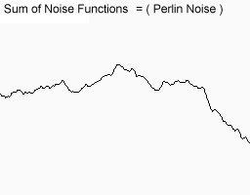[4]

The same concept is applied in 2 dimensions to generate the height map of the terrain.

### Tessellation

The height map needs to be converted into a set of triangles that can be rendered. We start with a flat M * N grid of rectangles in the XZ plane. The rectangles formed by the grid are divided into triangles which are the primitives for rendering. It can be observed that each vertex is shared by 6 adjacent triangles. To avoid duplicate vertex data, indices of the vertices forming the triangles are stored for rendering.

The values from the height map are then applied to the vertices in the grid. Rendering the triangles now results in the wire-mesh image of the mountain terrain.

Screenshots of the tessellated flat grid and the tessellated terrain.

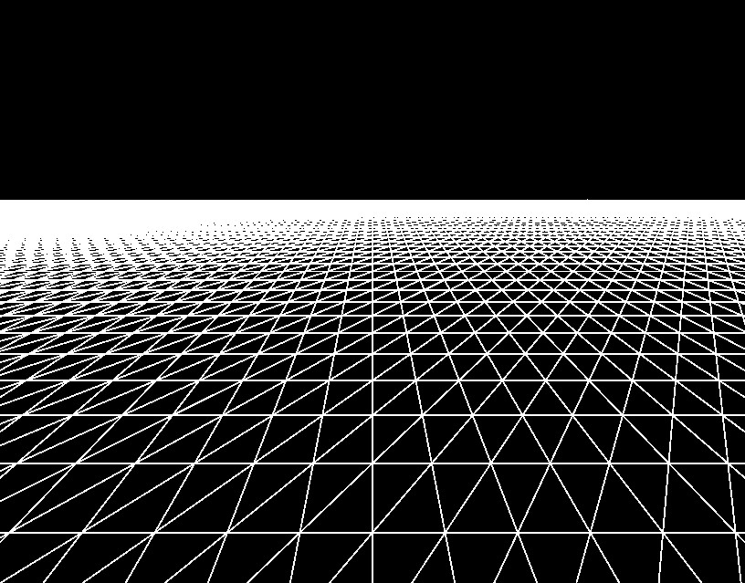 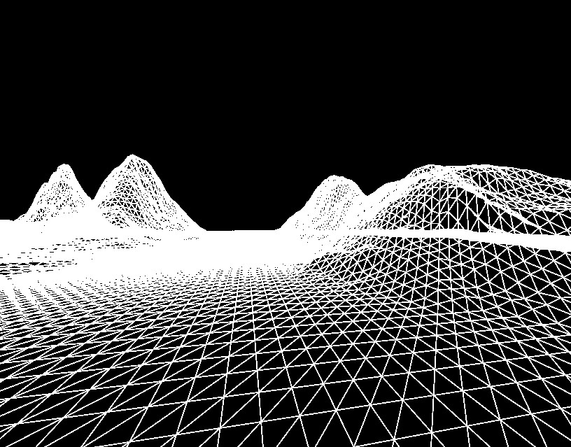

### Calculating Normals

For a triangle formed by 3 points a,b and c – the normal can be calculated using the following cross product:

$$n=\left(b-a\right) X (c-a)$$

For each quad in the grid, the normal is calculated for the upper right vertex as the average of the normals of the two triangles that form the quad. The second pass is a smoothening phase. For every vertex the normal is calculated as the average of the normal from all its neighboring vertices along with itself.

### Lighting

The normal calculated at each vertex will be used to implement lighting at the pixel shader. The program sets the directional light parameters. This includes the ambient light, the diffuse light intensity and the diffuse light direction. The pixel shader will use the Phong illumination model to calculate the intensity of each pixel on the terrain.

Screenshot of the lit terrain:

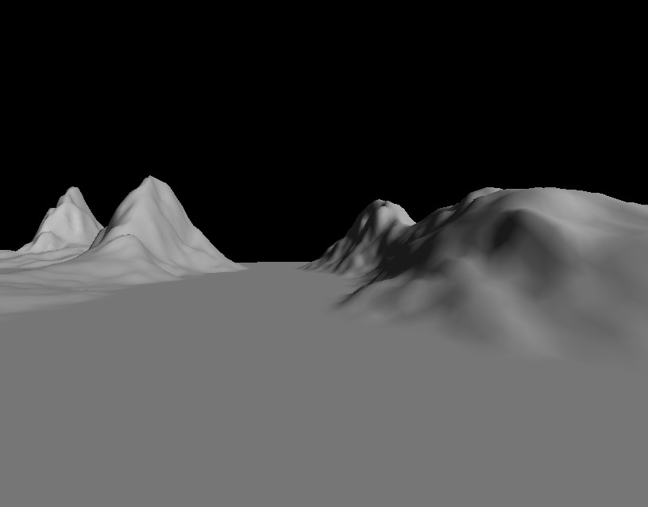

### Multi-Texturing

To perform the texturing of the terrain, we will try to mimic what we observe while looking at images of real mountain terrain. A noticeable observation is that areas of the terrain that have a high slope appear to be rocky and areas that are more flat appear to be relatively grassier. We will use this observation in our technique of texturing by applying a higher fraction of rocky texture to areas of the terrain with higher slope while applying higher fraction of grass texture to areas of the terrain with lower slope.

This slope factor can be easily calculated for each vertex in the fragment shader by taking the dot product of the up vector with the normal of the triangle being textured.

S = Up dot N where,  
S - is the slope factor being calculated  
Up - is the Up vector (0,1,0)  
N – is the normal calculated for the vertex

We then maintain a sea level and render a flat water texture for areas of the terrain that are at a height below the sea level. To make the transition between land and water look more natural, we interpolate the color contribution in the range of the transition.

After applying these techniques, I noticed that the image stretching along triangles of the terrain where the slope is high. This was being caused by the fact that the texture mapping technique was being applied only in the XZ dimension and did account for image stretching caused by the height. This problem was solved by applying tri-planar texturing - technique where the texturing is applied in 3 phases – the XY plane texture mapping, the YZ texture mapping and the XZ texture mapping. The contribution of the color calculated on each plane is varied depending on the normal. Eg: Flat surfaces receive higher contribution from the XZ plane texturing while steep surfaces receive higher contribution from the YZ plane texturing.

The multi-texturing along with lighting gives us the photorealistic mountain terrain that we target.

Screenshot after applying texturing techniques:

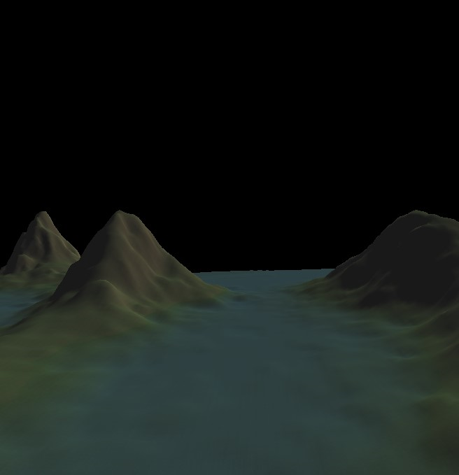

### Skybox

The skybox is implemented by rendering a cube centered on the camera position. Tile-able sky textures are rendered onto the 6 interiors faces of the cube. As the camera moves, the cube moves along and continues to maintain the camera position at its center. This gives the player a feel that the sky is at an infinite distance. It is important to render the skybox as far as the far plane so it does not beat any of the scene triangles in depth test.

This is a screenshot of rendering the skybox without and with rendering the terrain:

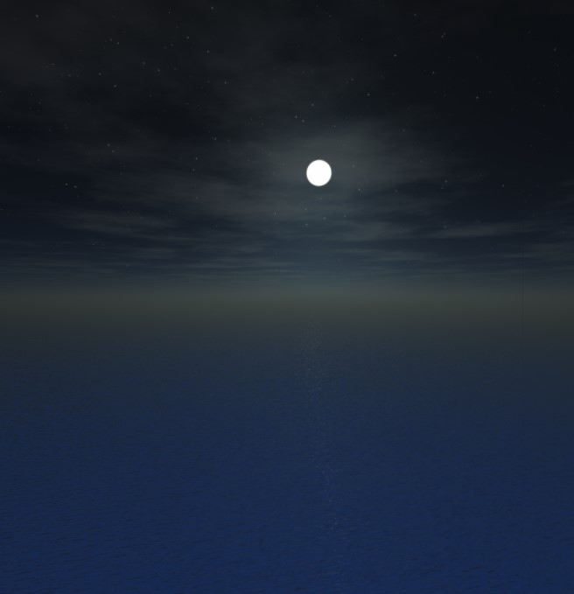 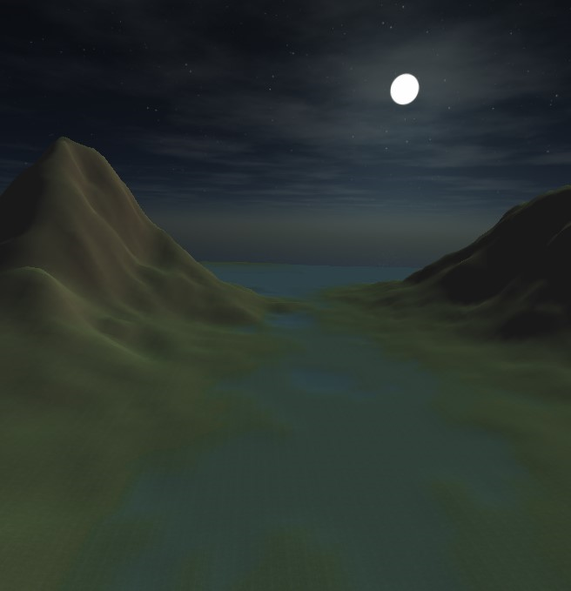

### Camera Controls

Simple camera controls are implemented to move the camera around in the 3d world. This is implemented by maintaining 3 values for the camera:

* Eye position (e) – position of the camera
* Look-at position (p) – the position in the 3d world that the camera is focused at
* Up vector (u) – the vector that is up relative to the view direction

Using the values, additional values can be calculated:

* View direction (v) = (p-e)
* Right vector (r) = u X v

Using these values, the following operations can be performed:

* Move forward/back: To move the camera forward/back we move the eye position and the look-at position along the View direction vector. We make sure the distance between the eye position and the look at position is preserved.
* Yaw: To implement yaw, we simply rotate the look-at position around the axis defined by the eye position and the up vector. We make sure the distance between the eye position and the look at position is preserved.
* Pitch: To implement pitch, we rotate the look-at position around the axis defined by the eye position and the right vector. Again, we make sure the distance between the eye position and the look at position is preserved.

## Performance Statistics

A separate window is rendered with performance statistics that are obtained in real-time from the scene rendering. This data is collected from profiling code embedded in the program. Performance statistics recorded include current FPS (frames per second), total number of triangles drawn, memory usage and CPU time for the overall program and for different stages.

Results captured:

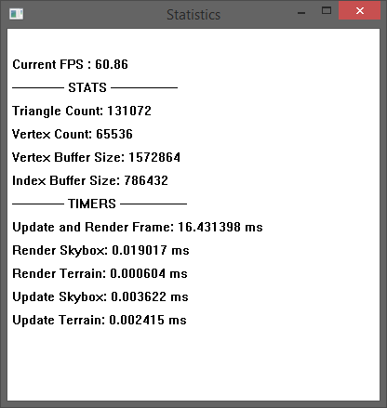

It was important for this project to show efficient performance statistics so that it is feasible for it to be adapted into larger projects. More complex scenes developed over this will require the majority of the frame time to achieve something beautiful or interactive.

## Challenges

### Sharp Transitions

By directly applying the techniques discussed above, we expect to see sharp transitions between vertices with respective to lighting and texturing. To prevent this, we will apply smoothing passes across the data sets. For the height map, we apply a smoothing phase where the height of each vertex is influenced by the heights of its neighbors. Shared normal will be calculated for each vertex making the lighting and texturing transitions across vertices more natural.

### Stretching of texture in areas with high slope

This was caused by the fact that a texture application is calculated in 2 dimensional space and did not account for the height of the triangles. This was solved by applying tri-planar texture blending.

### Sea level transitions

Maintaining a flat sea level across the terrain map made the transition between land and water look flat and sharp. To make this look more natural, I was required to interpolate the texture blend when transitioning from land and water. We will also need to work around a threshold sea-level at transitions, so it does not look the height at which the water appears is exactly the same across the terrain.

### Clipping

Since no form of collision detection is implemented, it is possible that the user flies through the terrain. To prevent this we could perform basic collision detection at each user move to find and prevent clipping through the terrain without implementing a full blown collision detection system. I considered this to outside the scope of the project and hope to address as future enhancement.

### Skybox Edges

Since the skybox is a fixed size cube around the camera position, it would break at the corners of the terrain because the terrain itself is finite. Choosing a skybox whose bottom face blends easily into the water texture could help make this less noticeable. To hide this from the user, we avoid the camera from flying to the edges of the terrain. It is important to render the skybox at the far plane so it does not beat any of the scene triangles in the depth test.

# Design and Implementation

### Window Creation

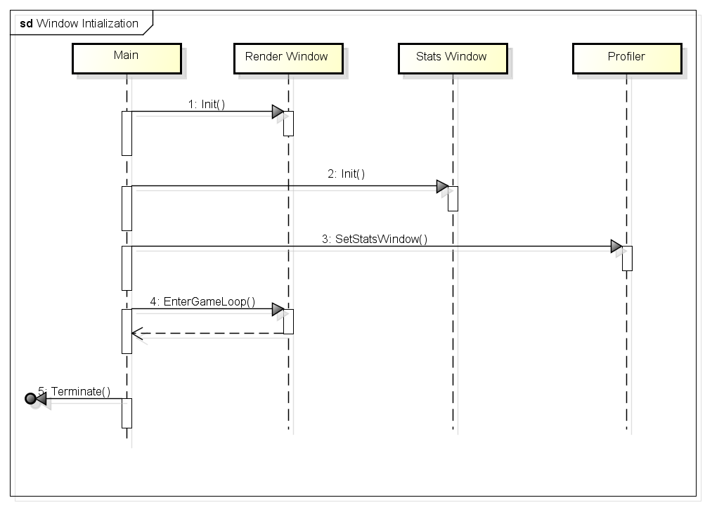

### Render System

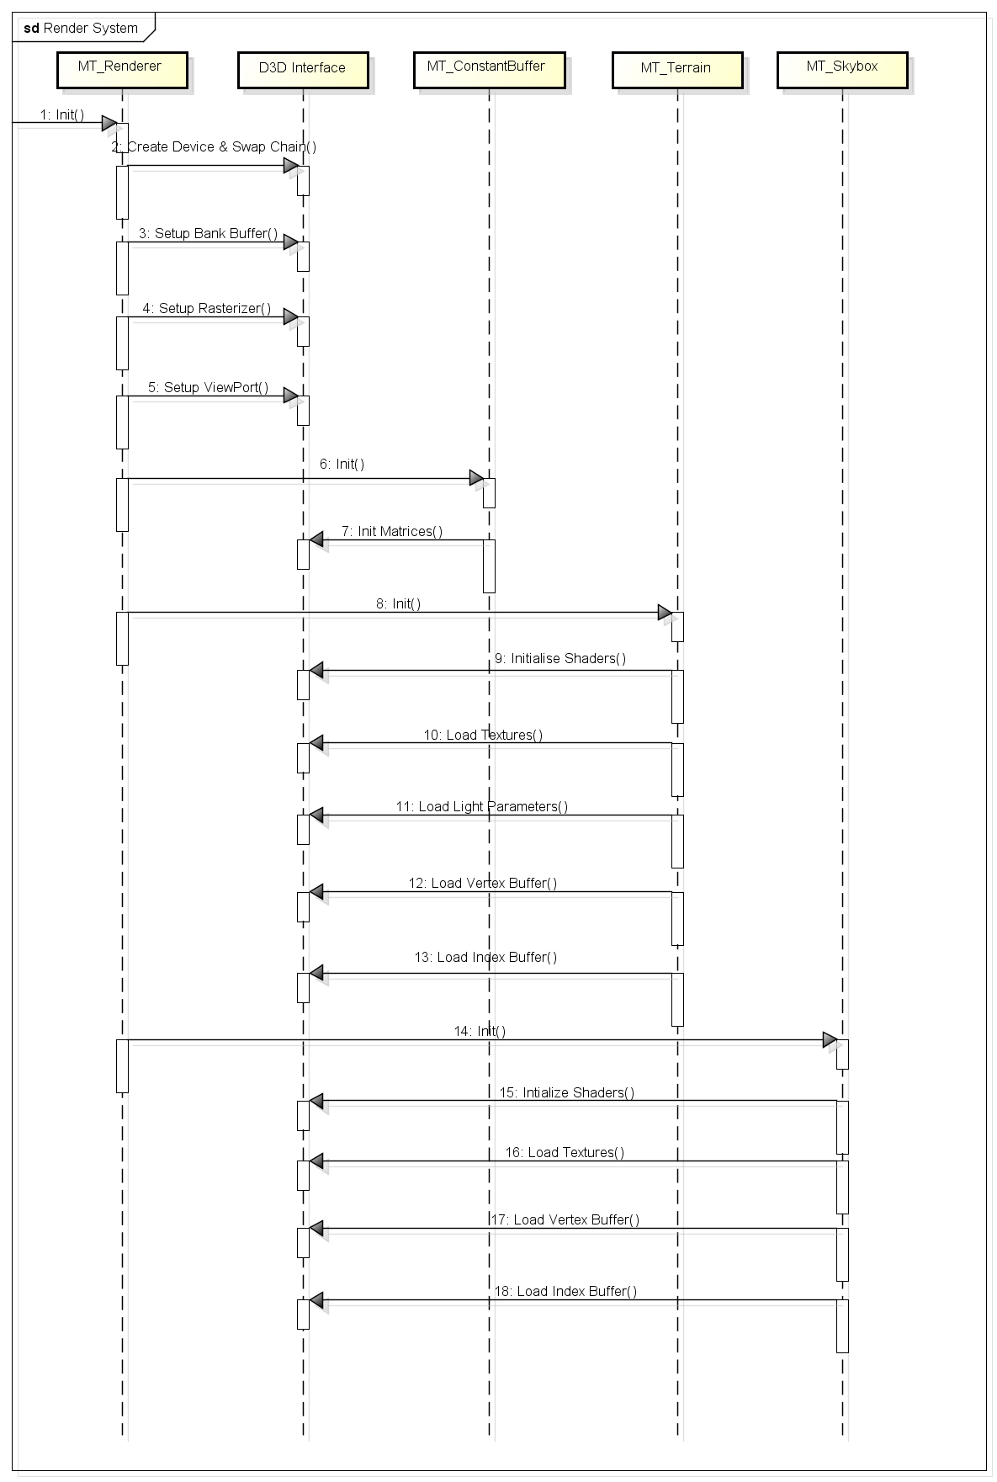

### Render Loop

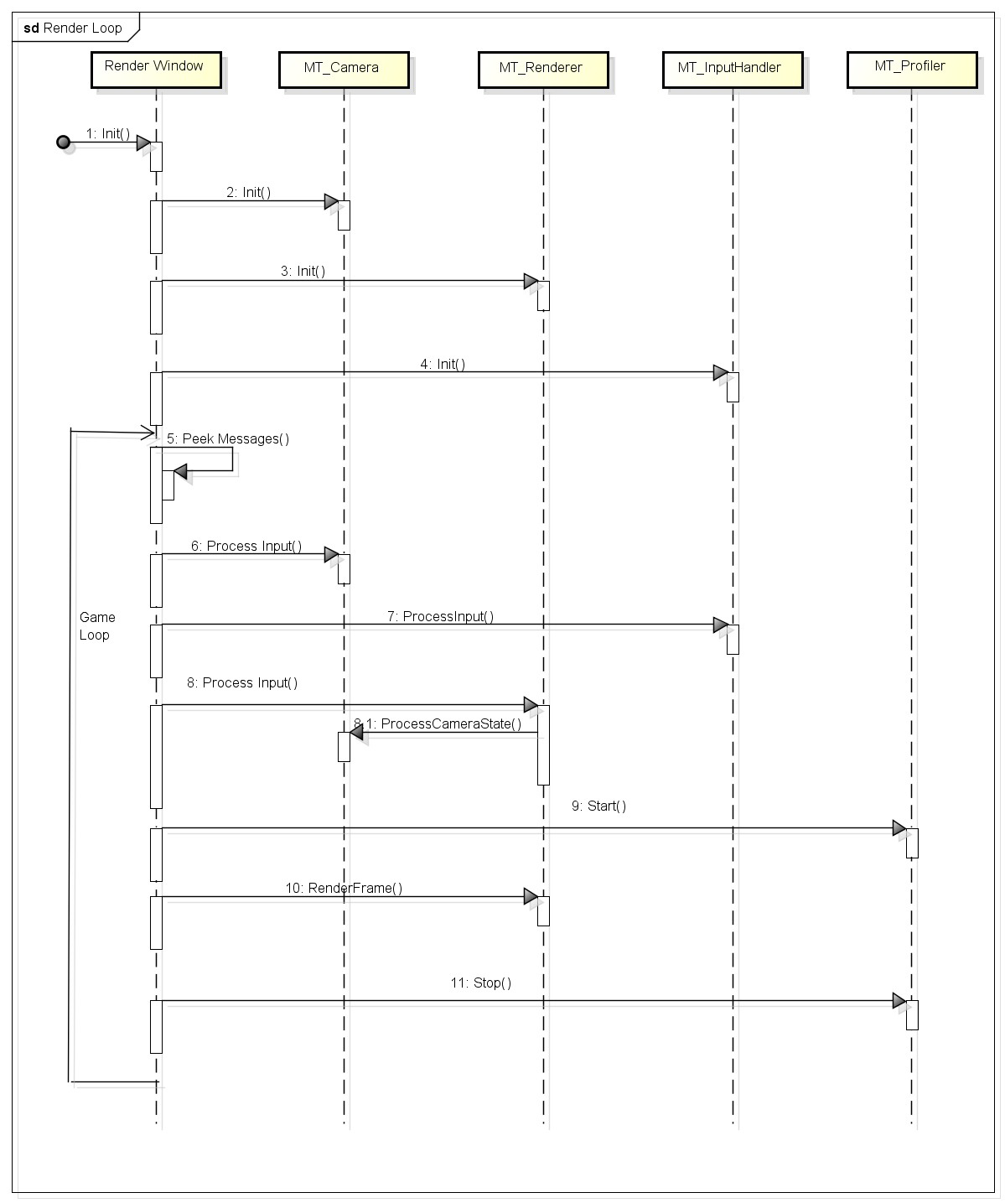

### Render Frame

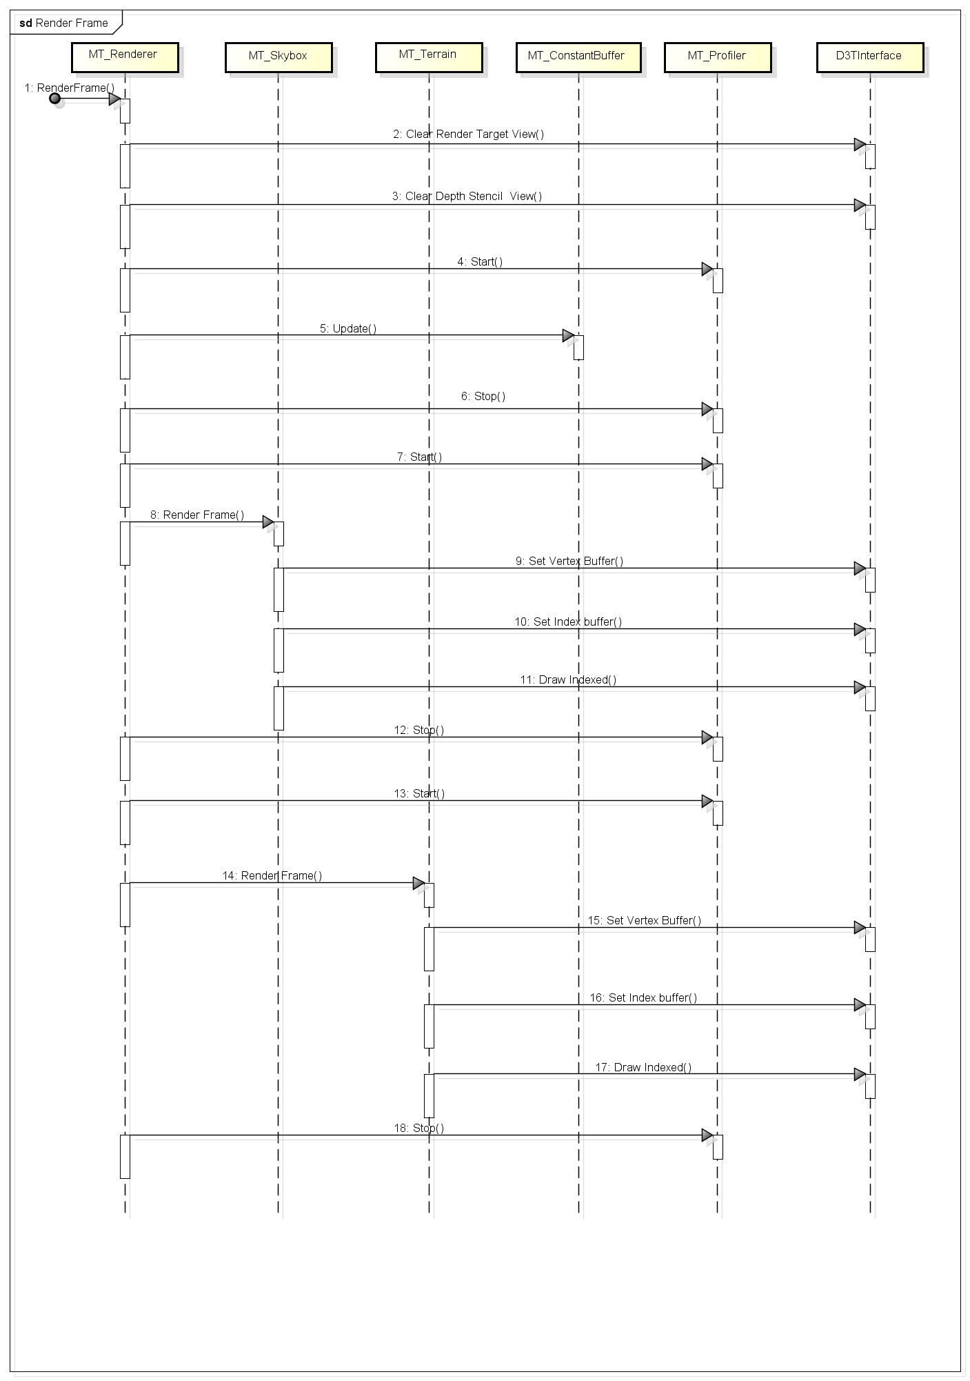

### User Interaction

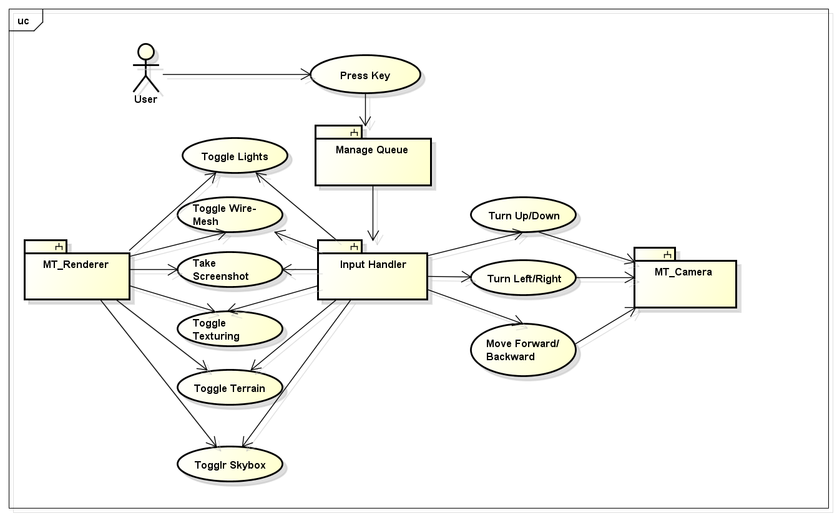

### Class Diagram

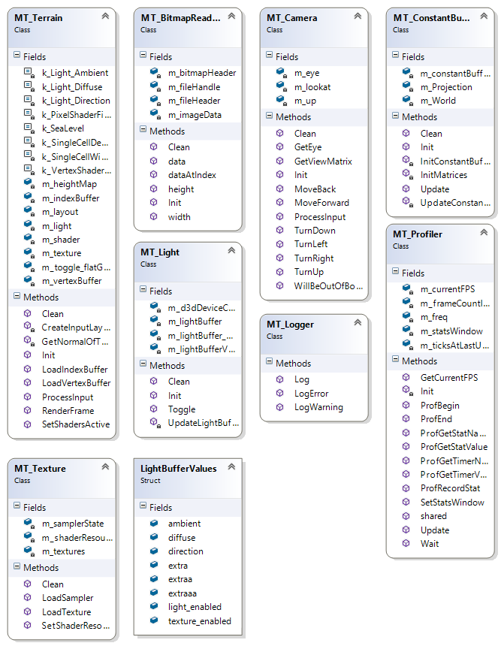

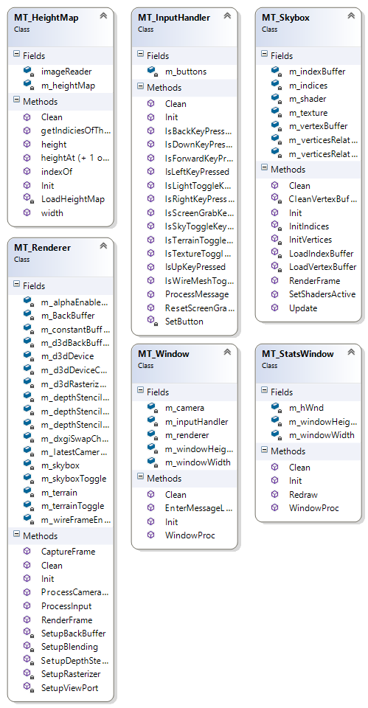

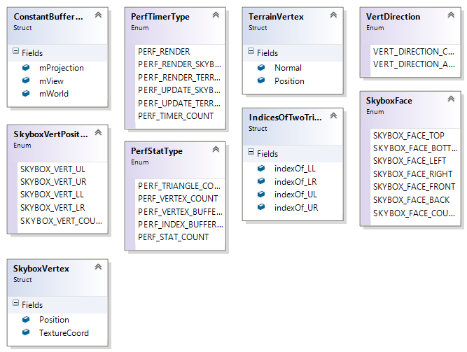

# Technology

### Development System Specifications

* Operating System - Windows 8.1 Pro 64 bit
* 16 GB RAM
* CPU – Intel® Core™ i5-3570K @ 3.40GHz
* GPU – NVIDIA GeForce GTX 770 2GB VRAM

### Software Development Kits

* Windows 8.1 SDK
* Direct X 11 SDK
* DirectXTK

### Development Environment

* Visual Studio 2013
* Github
* GitExtensions

# Program User Guide

## Running the program

Given the source code, we compile and build the 2 projects in the solution – “PerlinNoiseGenerator.sln” and “MountainTerrain.sln” in Microsoft Visual Studio 2013.

First we run the height map generation program – “PerlinNoiseGenerator.exe” to output a random height map in the form of the grey scale bitmap image. We then run “MountainTerrain.exe” to see the rendered mountain terrain scene. The scene can be navigated and tweaked using the input controls described below in the “Input” section. Some screenshots are also attached in the “Screenshots” section.

## Input

The program can be interacted with to navigate the scene using the fly through camera or to switch off/on features. The following keys are supported.

* ‘w’ – Move camera forward
* ‘s’ – Move camera back
* ‘a’ – Yaw camera left
* ‘d’ – Yaw camera right
* ‘e’ – Pitch camera up
* ‘c’ – Pitch camera down
* ‘k’ –Screen shot
* ‘l’ – Toggle Lighting
* ‘m’ – Toggle wire-mesh
* ‘t’ – Toggle texturing
* ‘1’ – Toggle terrain
* ‘2’ – Toggle skybox

## Screenshots

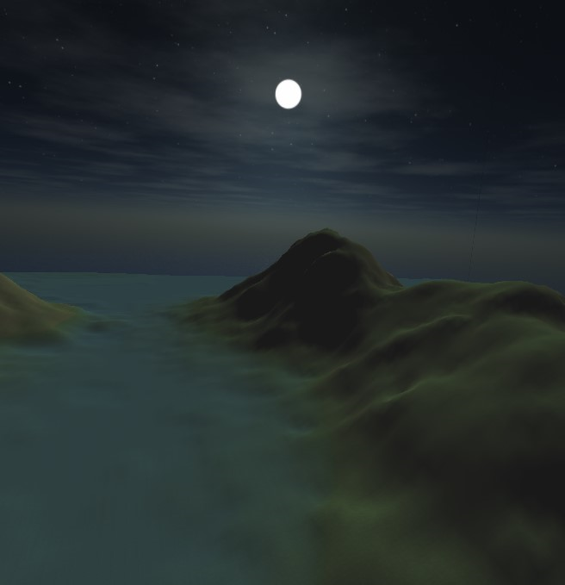 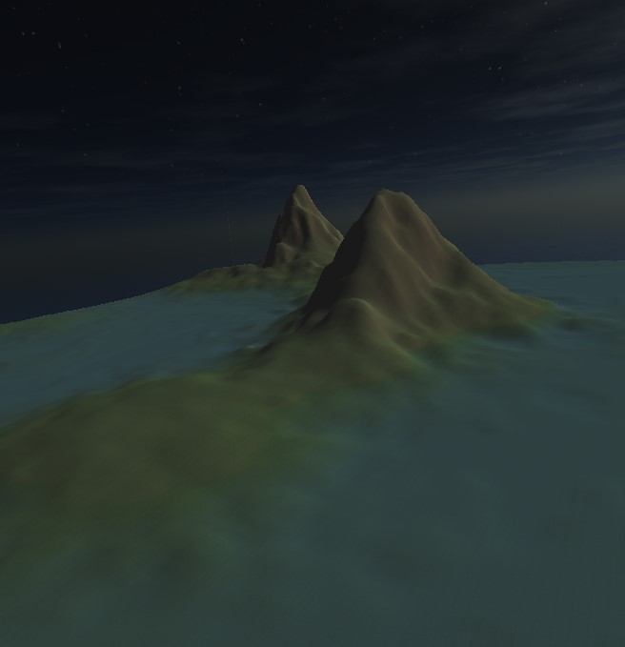

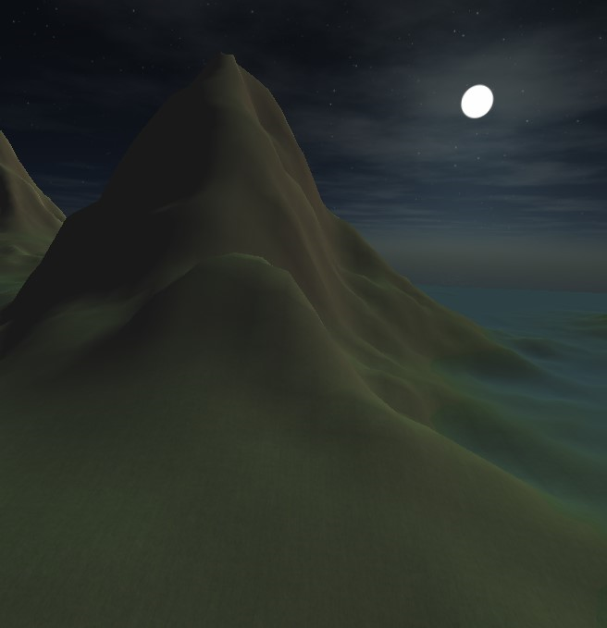 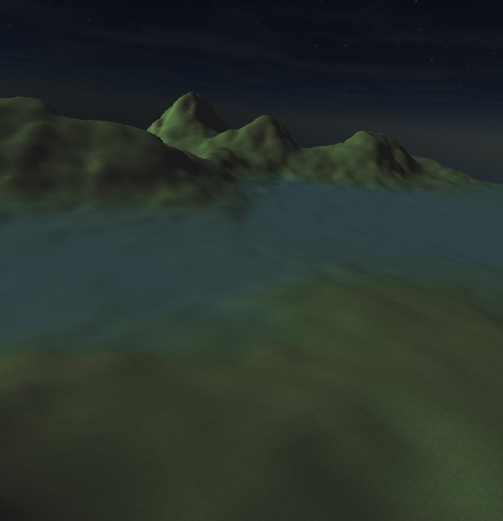

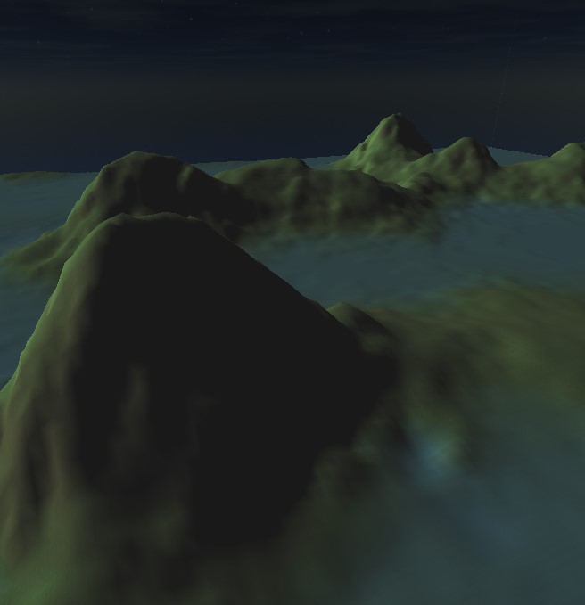 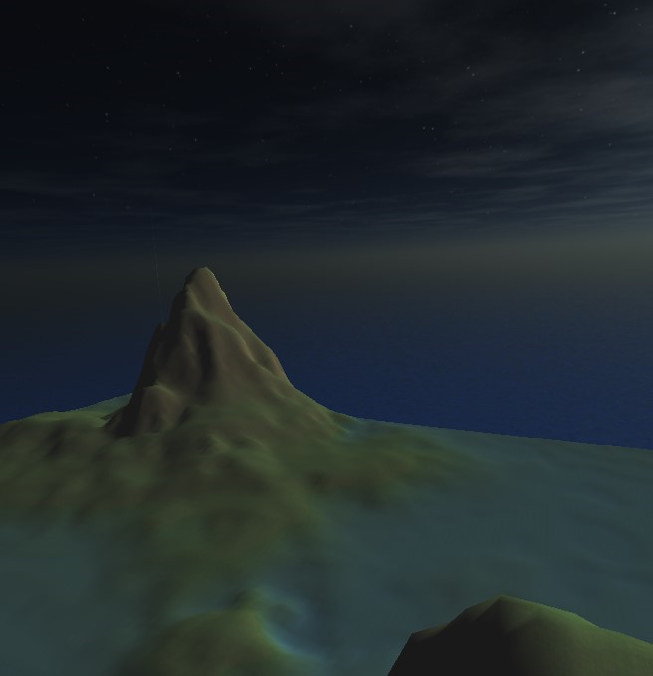

# Conclusion

The multi-texturing technique introduced in this project is intuitive and easy to work with because it mimics the way real terrain looks. The final texturing of the terrain can be adjusted elaborately by tuning the blending of rock, grass and water textures. This technique is scalable and additional layers of texture such as snow or soil can be added easily. This technique will also allow us to use large high quality texture images because each texture is applied onto a region of the terrain matching its dimension and maintaining its detail.

This project also demonstrates that the proposed multi-texturing technique can easily be adopted along with some of the popular techniques. It also demonstrates that the combination of techniques described can be used to render photo-realistic mountain terrain while also allowing it be customized easily using the different parameters exposed. The performance statistics to be collected under different parameters are expected to prove that the solution is efficient and scales easily with the scene requirements.

The techniques used to implement the solution are intended to be intuitive and options in the working demo will allow the user to understand the contribution of each stage in isolation. This will allow these techniques to be understood before being adapted into larger projects or to simply explain the techniques to a graphics enthusiast. The solution will also be made customizable to assist the same.

# Future Enhancements

### Shadow Mapping

The current lighting model implemented is only able to show areas that are lit differently but does not cast shadows. Shadows can be implemented by using many of the techniques used to lighting by simply looking into the scene from the light source – areas of the scene that are not visible from the light source are in-shadow. Implementing shadows will increase the photo-realism of the scene.

### Tessellation Shader

The shader pipeline in DirectX 11 now allows us to add a phase of tessellation executed in the shader by the GPU. By procedurally increasing the geometric complexity of the terrain, it will look less flat and more realistic.

### Terrain Editor

A combination of two approaches here is what will result in good looking terrain. An artist’s input in composing the terrain is useful, but becomes almost impossible for an artists to complete compose the terrain model by hand. Providing the artists with a random terrain generation tool that can be edited is what is effective.

### Ocean Shader

The water in this terrain scene will look much for convincing if it made waves. This can be implemented in the shader.

### User Interface

Adding a user interface that provides hints to the user to help navigate, control and tweak the scene will make the demo program a good example to explain the concepts of lighting, rendering and texturing to a new graphics enthusiast.

### Segway to a Game Engine

I would like to use this project as a basis to start developing my own game first person shooter game engine. Although this only scratches the surface of what is needed for a game engine, it gives me the confidence as a start.

# Deliverables

1. Height map generation program
2. Working demo of the described Mountain Terrain scene
3. Multiple screen shots taken from the demo
4. A final report including the performance statistics observed using different scene-parameters
5. A presentation for the final project defense

# References

1. **Computer Rendering of Fractal Curves and Surfaces  
   Loren C. Carpenter  
   Boeing Computer Services  
   Seattle, Washington  
   ACM SIGGRAPH Computer Graphics - Preliminary papers to be published in Communications of the ACM Homepage archive**

**Volume 14 Issue SI, July 1980**

**Pages 9 - 9**

1. **An Image Synthesizer  
   Ken Perlin  
   Courant Institute of Mathematical Sciences  
   New York University  
   SIGGRAPH '85 Proceedings of the 12th annual conference on Computer graphics and interactive techniques**

**Pages 287-296**

1. **Improving Noise**  
   Ken Perlin  
   Media Research Laboratory  
   Dept. Of Computer Science  
   New York University  
   SIGGRAPH '02 Proceedings of the 29th annual conference on Computer graphics and interactive techniques

Pages 681-682

1. **Perlin Noise**  
   <http://freespace.virgin.net/hugo.elias/models/m_perlin.htm>
2. **The Ultimate DirectX Tutorial**  
   <http://www.directxtutorial.com/Lesson.aspx?lessonid=11-1-3>
3. **Generating Random Fractal Terrain**  
   <http://gameprogrammer.com/fractal.html>
4. **Multi-textured Terrain in OpenGL**  
   <http://3dgep.com/?p=1116>
5. **Introduction to OpenGL for Game Programmers**  
   <http://3dgep.com/?p=636>
6. **Skybox tutorial**  
   <http://sidvind.com/wiki/Skybox_tutorial>
7. **Multi Texturing in OpenGL**  
   <http://berkelium.com/OpenGL/GDC99/multitexture.html>
8. **Tri-planar texture mapping for better terrain**

<http://gamedevelopment.tutsplus.com/articles/use-tri-planar-texture-mapping-for-better-terrain--gamedev-13821>

# Author Information

/*-------------------------------------------------------------------------------------------------------------------*/

Karteek Kumar Mekala  
Masters of Science – Computer Science  
Rochester Institute of Technology  
[Karteek.Kumar.M@gmail.com](mailto:Karteek.Kumar.M@gmail.com)  
[kkm6815@rit.edu](mailto:kkm6815@rit.edu)  
/*-------------------------------------------------------------------------------------------------------------------*/